Week of 3/6:

- motion correction of subj 5

3/21

- attempted slice timing correction but couldn't figure out the Slice order acquisition method

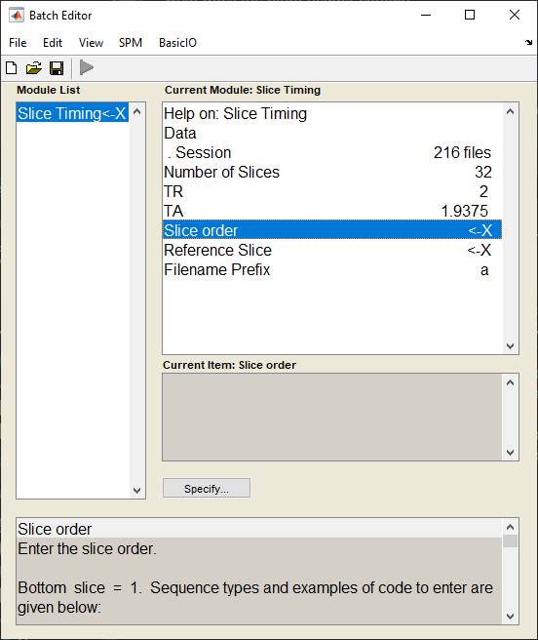

Amjad suggested we don’t correct for it. But we ended up doing it with bottom up interleaved.

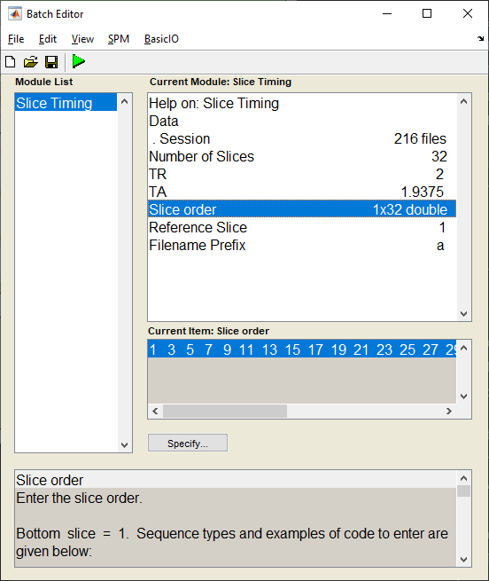4/18/2023

Since sub5 is missing structural, we changed him

* Realign (Est, Reslice) sub 4 func
* Slice timing
* Coregister (Est&Re)
  + We’re limited by affine transfomrations
* Normalize (Write)
  + 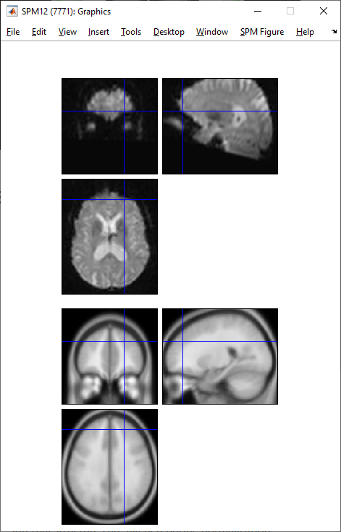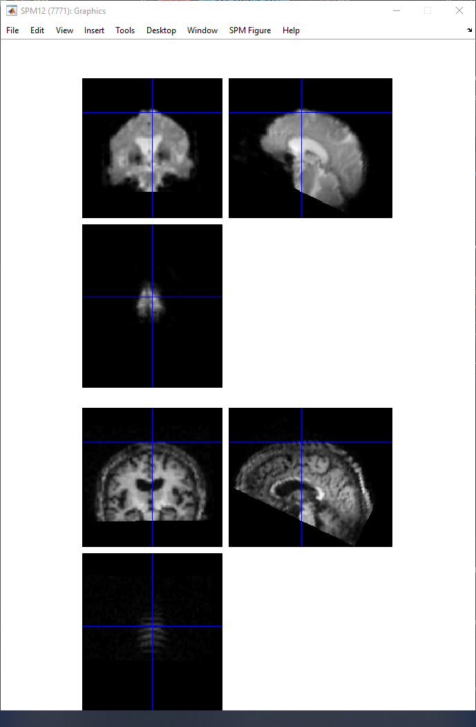Warp!

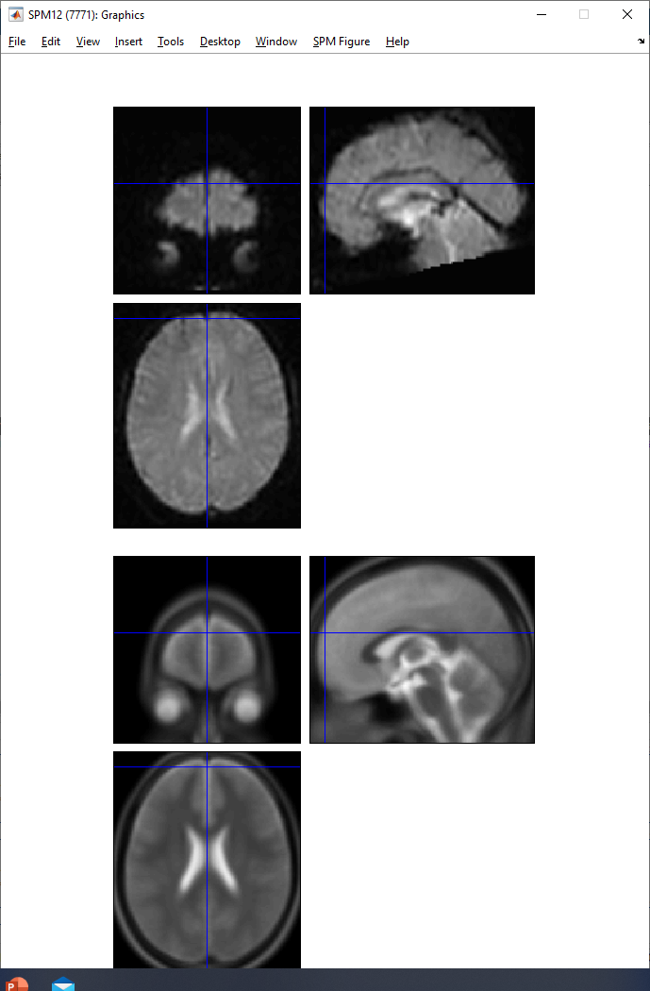

4/19/23

* Normalized all subjects (except 5 AD & NCS)
* Error in batch normalization of structural files
* The functional seem fine when check register with canonical T2 file in SPM

4/24/23

* Figured out that just doing variance thresholding (batchFeatures.m) results in feature vectors of different lengths [it was assumed that preprocessing didn’t normalize properly]
* Then we looked to PCA for feature selection (it essentially calculates variance anyways)
* We saw that only the first principle component carries >99% of variance
  + We also saw that some PC analysis on certain subjects returned NaN for some reason (and they were dropped
  + So now we have feature_matrix_AD of subj4,6,7,8,9,10 and NCS of subj7,8,9,10
* To visualize the impact of this PC we plotted the umap and it did show a significant difference between the two groups

ansNCS =

-1.6133 -23.2604

-1.6223 -22.0073

-0.4956 -22.1785

-0.4731 -23.5125

ansAD =

25.9990 10.3760

25.6930 11.4168

24.3283 9.5390

24.7331 10.5176

23.6670 10.6738

24.4464 11.5173

nvm

5/2/23

Hyperpca didn’t work

Cp_decomposition didn’t work because Matrix is singular or badly scaled

Warning: Matrix is singular,

close to singular or badly

scaled. Results may be

inaccurate. RCOND = NaN.

> In cp_als (line 145)